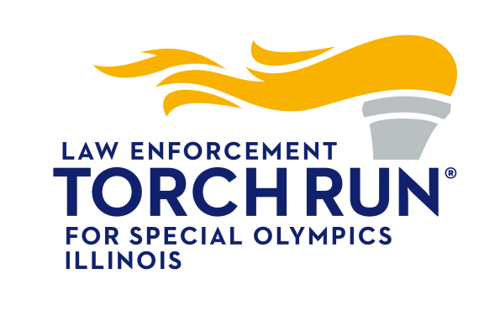
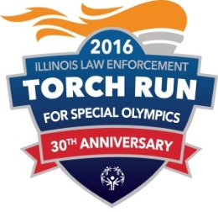
Country Club Hills PD Announces Fundraising Campaign for
Torch Run 2016 Benefitting Special Olympics Illinois

On Tuesday, June 9th 2016, the Country Club Hills Police Department will again be participating in the Annual Illinois Law Enforcement Torch Run for Special Olympics Illinois. Special Olympics Illinois is a non-for-profit organization offering year-round training and competition in 19 sports for nearly 22,000 athletes with intellectual disabilities and nearly 21,000 Young Athletes (ages 2-7) with and without intellectual disabilities. Special Olympics transforms the lives of people with intellectual disabilities, allowing them to realize their full potential in sports and in life. Special Olympics programs enhance physical fitness, motor skills, self-confidence, social skills, and encourage family and community support.

The Country Club Hills Police Department hopes that you consider supporting our efforts to help transform the lives of Special Olympic athletes from across Illinois. Last year, the police department raised $4,900; with this year’s goal being $5,500. We ask for your support to sponsor our runners who will be running to raise awareness and money for this worthwhile cause. 100% of your tax-deductible contribution goes directly to Special Olympics Illinois, which is a 501(c)(3) charitable organization (Tax EIN: 36-2922811).
The cost of sponsorship is $100.00 per runner; Special Olympics Illinois will send a thank you/tax letter to each donor of $100 or more. If you are unable to sponsor a runner, a donation in any amount will be greatly appreciated. Donations may be made payable to Special Olympics Illinois and mailed to:
Country Club Hills Police Department
Attn: Sgt. Brown
3700 W. 175th Pl
Country Club Hills, IL 60478

Thank you for your support which is deeply appreciated by the Police Officers, the City Council, Citizens of Country Club Hills, and most of all the “Illinois Special Olympians.”
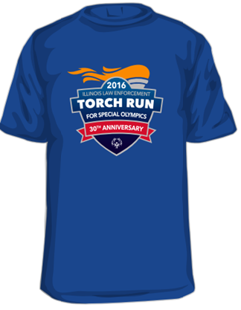
Torch Run Merchandise & Raffle Tickets
Available for Purchase at:
Country Club Hills Police Department
3700 W. 175th Pl, Country Club Hills, IL 60478
&
Cop on Top Kickoff Event – on Friday May 20th, 2016
Dunkin’ Donuts – 4021 W. 183rd St, Country Club Hills, IL 60478

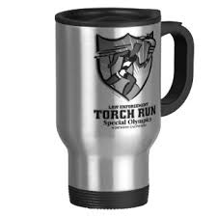
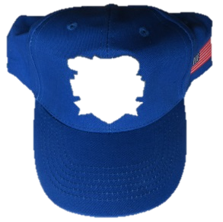

Shirt $15 Hat $15 Coffee Mug $10 Lapel Pin$5

If you have any questions or would like further information in regards to Torch Run merchandise, participating or contributing, please contact Sgt. Brown at cbrown@countryclubhills.org.
